
P.S.R. ENGINEERING COLLEGE SIVAKASI-626 140

(An Autonomous Institution, Affiliated to Anna University, Chennai)

QUESTION BANK

Programme: | B.E. | Branch | Electronics and Communication Engineering
Acad. Year: | 2018-2019 | Year/Semester | III Yr/V Sem
Course Code: | 161EC51 | Course Name | Control Systems
Course Tutor: | Dr.K.Valarmathi, Prof/ECE and Mrs.P.Lingeswari AP/ECE

(Semi Log graph, Polar graph and linear graph sheets may be permitted)

UNIT-I CONTROL SYSTEM MODELING
PART - A

Distinguish between open loop and closed loop systems.
What is meant by a control system?
List the applications of closed loop systems.
List the applications of open loop systems.
Define Masons gain formula.
What are the characteristics of negative feedback?
Define transfer function.
What are the properties of signal flow graph?
What are the basic elements used for modeling mechanical rotational system?
What is the rule for moving the summing point ahead of a block?

PART- B

 | i) Design the torque-voltage electrical analogous circuit and verify by writing mesh equations.  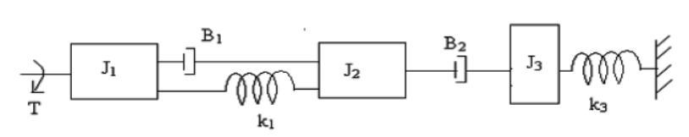 | 10
 | ii) Design the mathematical model for the following electrical system.  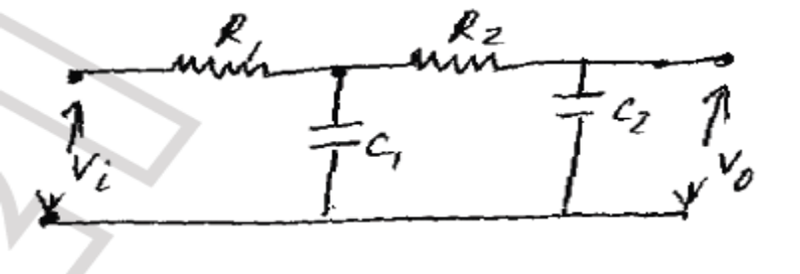 | 6
 | i) Design the transfer function Y₂(s)/F(s) for the mechanical translational system shown in Figure.  M1  B  K₁  M2  K₂  Y₁  Y₂  F(t) | 10
 | ii) Design the mathematical model for the following mechanical rotational system.  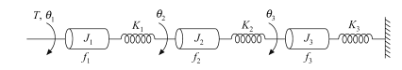 | 6
 | i) Construct the transfer function C(S)/R(S) using the block diagram reduction technique for the system shown in figure.  C(s)  G₁  R(s)  +  G₂  H₁  _  +  +  G₃ | 10
 | ii) Design the transfer function model for the field controlled DC motor. | 6
 | i) Find the closed loop transfer function of the system shown in fig. using the block diagram reduction technique.  G₂  C(s)  +  _  H₁  H₂  H₃  +  _  G₁  +  _  R(s) | 8
 | ii) Design the transfer function model for the Armature controlled DC motor. | 8
 | Find the overall gain of the system whose signal flow graph is shown in Figure.  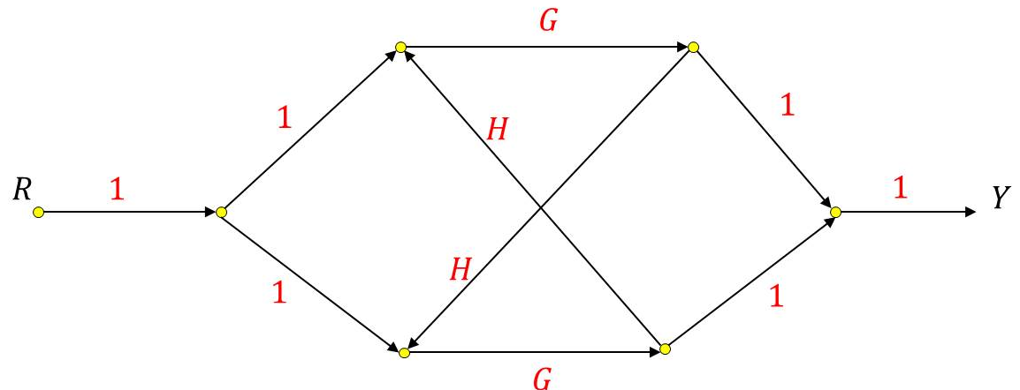 | 16
 | Find the overall gain of the system whose signal flow graph is shown in Figure.  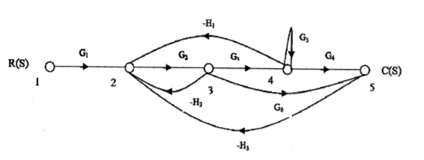 | 16

UNIT-II TIME DOMAIN ANALYSIS
PART – A

What are the different standard test signals?
For the unity feedback system having 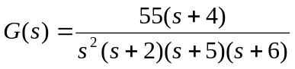determine the type and order of the system.
What is the effect of PI controller on the system performance?
Define peak time.
What are transient and steady state response of a control system?
How do you find the type of the system?
What are the advantages of generalized error co-efficient over static error co-efficient?
Why derivative controller is not used in control system?
How is control systems classified depending on the value of damping?
The closed loop transfer function of a second order system is given by 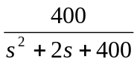 Determine the damping ratio and natural frequency of oscillations.
Define settling time.

PART- B

 | i) Develop an expression for the time response of critically damped second order system subjected to unit step input. | 10
 | ii) The unity feedback is characterized by an open loop transfer function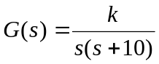. Determine the gain K, so that the system will have a damping ratio of 0.5 for this value of K. Determine settling time and peak overshoot for a unit step input. | 6
 | Consider a second order model 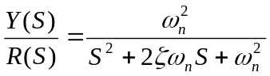 ; 0<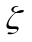<1. Find the response y (t) to a unit step function. | 16
 | The open loop transfer function of a unity feedback system is given by G(s)=K/ s(sT +1) , where K and T are positive constant. By what factor should the amplifier gain K be reduced, so that the peak overshoot of unit step response of the system is reduce from 75% to 25%. | 16
 | i)The open loop transfer function of a unity feedback control system is 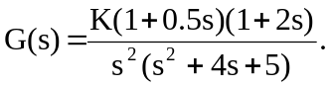 Determine the position, velocity and acceleration error constants and the steady state error for  - unit step  - unit ramp  - unit parabolic inputs. | 10
 | ii) Discuss about the system response of PI controller. | 6
 | i) Calculate the K_{p},K_{v},K_{a} for the following systems and also find the steady state error e_{ss} for r(t)=1+t.  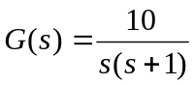 | 10
 | ii) Elaborate the system response of PD controller. | 6
 | i) A unity feedback control system has the forward transfer function is 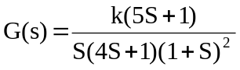. When the input 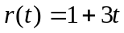. Find the minimum value of k so that the steady state error is less than 0.1. | 8
 | ii) The closed loop transfer function of a system subjected to a unit step input is 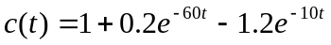. Obtain the expression for the closed loop transfer function. Also determine the undamped natural frequency and damping ratio of the system. | 8
 | i) Find the transfer function for an undamped second order system for unit step input. | 8
 | ii) Solve the positional and velocity error coefficients for the system with transfer function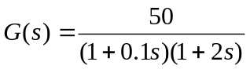. | 8

UNIT-III FREQUENCY DOMAIN ANALYSIS
PART - A

List the advantages of frequency response analysis.
Define corner frequency.
Name the frequency domain specifications.
Define phase margin and gain margin.
What are M and N circles?
What are the necessary and sufficient conditions for stability in Routh Hurwitz criterion?
Define relative stability.
What is the advantage of using root locus for design?
What are dominant pole?
Define marginal stability.
How stability is attained in control systems?
What is limitedly stable system?
What is Nyquist stability criterion?
Define unstable system.
How will you find root locus on real axis?

PART- B

 | Design the Bode plot for the transfer function 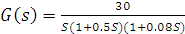 | 16
 | The open loop transfer function of a unity feedback system is given by. Outline the polar plot and determine the gain margin and phase margin. | 16
 | A unity feedback system has G(S)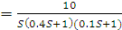 . Design the Bode diagram and obtain the gain and phase crossover frequencies. | 16
 | The open loop transfer function of a unity feedback system is given by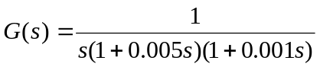. Outline the polar plot and determine the phase margin. | 16
 | i) Discuss about the M and N circles. | 10
 | ii) With suitable response curves, explain how the roots of the characteristic equation decides stability of the system. | 6
 | Outline the root locus of the system having 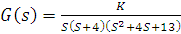. | 16
 | i) Consider the sixth order system with the characteristic equation Use Routh Hurwitz criterion to examine the stability of the system. | 8
 | ii)Find the range of k such that the closed loop system is stable whose characteristic equation is 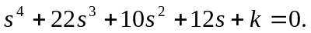 | 8
8. | i) The open loop transfer function of a unity feedback control system is given by 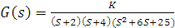 . By applying the Routh Hurwitz criterion, discuss the stability of the closed loop system as a function of K. | 8
8. | ii) Determine the range of k such that the closed loop system is stable whose characteristic equation is 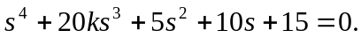 | 8
9. | Outline the root locus for the system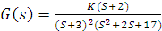. | 16

UNIT-IV DIGITAL CONTROL SYSTEM
PART - A

Define sampled data system.
What is zero order hold circuit?
Define z-transform.
Define sampling theorem.
What is meant by ROC of Z transform?
Distinguish between ‘S’ plane and ‘Z’ Plane.
Define initial value theorem and final value theorem for Z-transform.
What is aliasing and how it is overcome?
List the methods used to test the stability of linear discrete time system.
What is pulse transfer function?
List the necessary conditions to be satisfied for the linear discrete time system to be stable.

PART- B

 | i)Determine inverse Z transform of 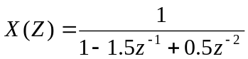 for ROC >1 | 8
 | ii) Evaluate the inverse Z transform of 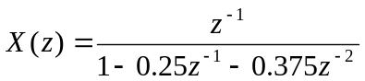. | 8
 | Explain in detail about sampling theorem and how it is reconstructed for a band limited signal. | 16
 | Obtain the impulse response of the linear discrete time system described by 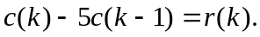 | 8
 | Find the z-transform of the output for the linear discrete time system described by | 8
 | Obtain the pulse transfer function H(z) for the system  a)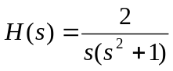 b) 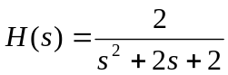 | 16
 | Determine the stability by using Jury’s stability analysis of the system whose characteristic equation are given below  - 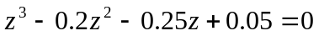 | 16
 | For the sampled data control system, shown in fig. where 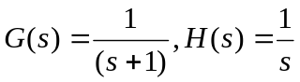and zero order hold 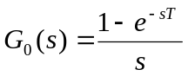. Assume sampling period = 1sec.  Find the unit step response. | 16
 | For the sampled data control system, shown in fig. find the response to unit step input where 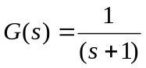. | 16

UNIT-V STATE VARIABLE ANALYSIS
PART - A

List the properties of state transition matrix.
What are the advantages of state space approach?
Define controllability.
Define sampling theorem.
What is state transition matrix?
Mention the procedure to convert electrical system to state space representation.
List the two types available in solving the state equations.
Define state and state variable.
List the applications of control system.
Define observability.

PART- B

 | Solve the state equation for the following state space model  . Subject to the initial conditions | 16
 | Examine the controllability and observability of the following system given below.  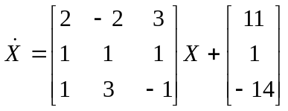 and 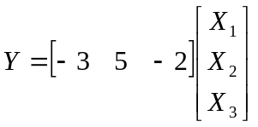 | 16
 | The state space representation of a system is given below  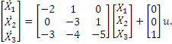 y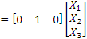. Determine the transfer function. | 16
 | Obtain the state space representation of observable canonical form: 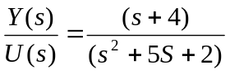 | 16
 | Consider the system with the state equation  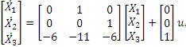 Prove the controllability of the system. | 16
 | Examine the controllability of the following system given below.  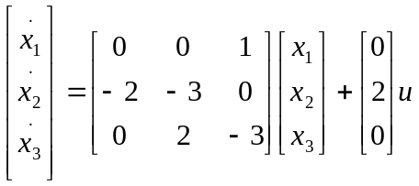 and 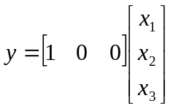 | 16

